ImageTrend Polymer Platform

https://www.polymer-project.org/1.0/

**By**

**Hooligan Anthony Pearson**

# Introduction

This is a document to learn Polymer and how to set it up. This document will later discus more concepts to make a framework in Polymer. Document work based on Windows 10. Experience in web design required.

Polymer is made by Google.

Polymer is a lightweight library that helps you take full advantage of Web Components.

With Web Components, you can create reusable custom elements that interoperate seamlessly with the browser’s built-in elements, or break your app up into right-sized components, making your code cleaner and less expensive to maintain.

Google also includes a toolbox to build Progressive Web Apps

Progressive Web Applications take advantage of new technologies to bring the best of mobile sites and native applications to users. They're reliable, fast, and engaging.

The Toolbox provides a component-based architecture, responsive layouts, a modular router, localization support, turnkey support for local storage and offline caching, and efficient delivery of unbundled app resources.

# Getting Set Up

<https://www.polymer-project.org/1.0/start/toolbox/set-up>

## Install Git, Bower, and Polymer CLI

Install **Git**. Use default set up options. <https://git-scm.com/downloads>

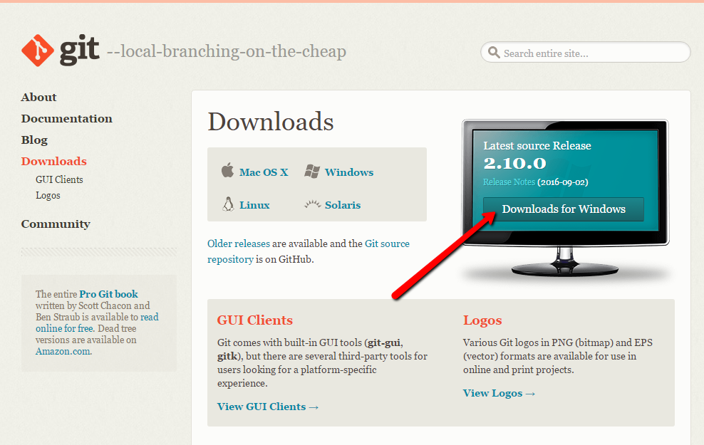

Install the LTS version (4.x) of Node.js. The current version (6.x) should work, but is not officially supported. Versions below LTS are not supported. Go through install set up with all defaults.

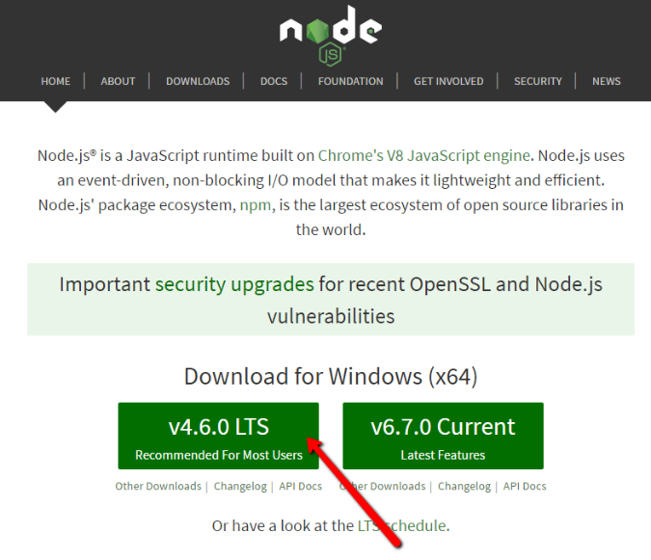

Install **Bower**. Open command prompt and type in:

npm install -g bower

Install the **Polymer CLI**. Type in:

npm install -g polymer-cli

Lots of stuff will show up on your screen.

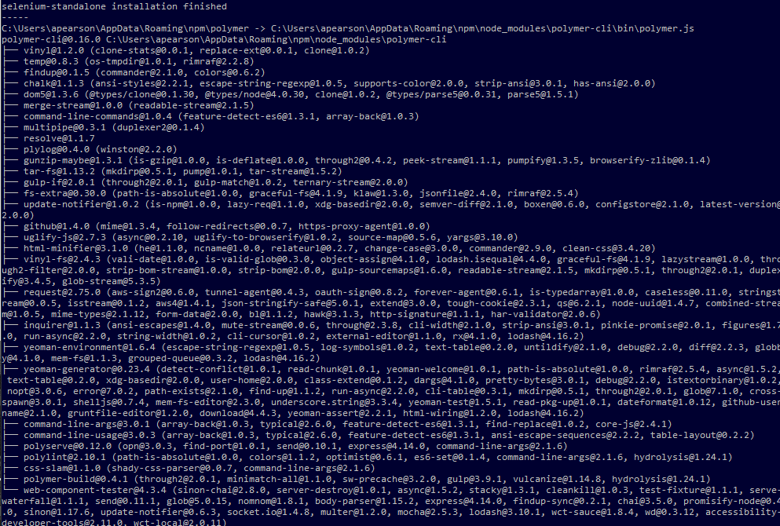

Test if you have the Polymer CLI (Command Line Interface) installed. Type in:

polymer

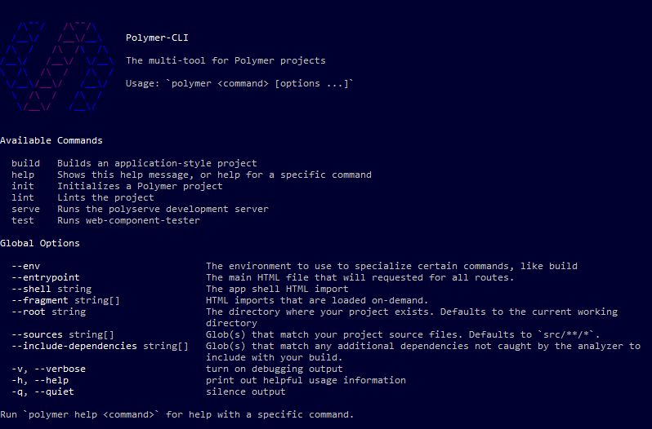

## Initialize a Blank Project

You can place your project anywhere you want but we will do it in the root directory. Let’s navigate there. Type in:

cd /

Let’s create a folder for our project. Type in:

mkdir imagetrend-app

Make imagetrend-app your current directory. Type in:

cd imagetrend-app

No let’s create our project in the directory. Type in:

polymer init

Select the second one using the up and down arrow keys and pressing enter.

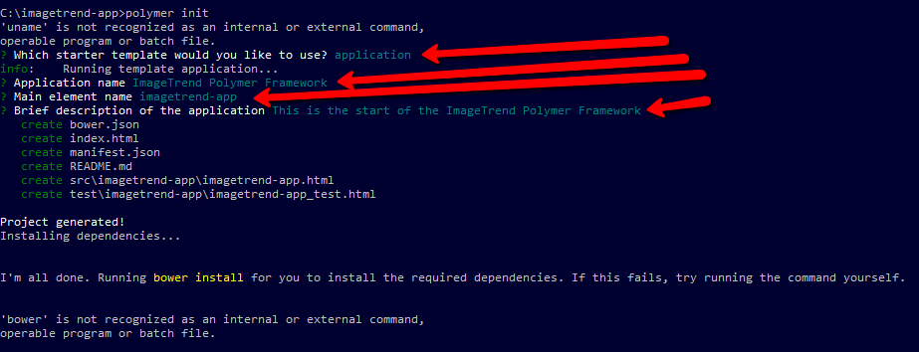

Then go through and answer the questions. We need to install all dependancies. Type:

bower install

The command above will get all dependencies for the app as defined in the bower.json file. Each dependency is its own component and can be updated by the polymer team. You can run that command anytime to check and install updates. Now we can run the app. Type in and allow access:

polymer serve --open

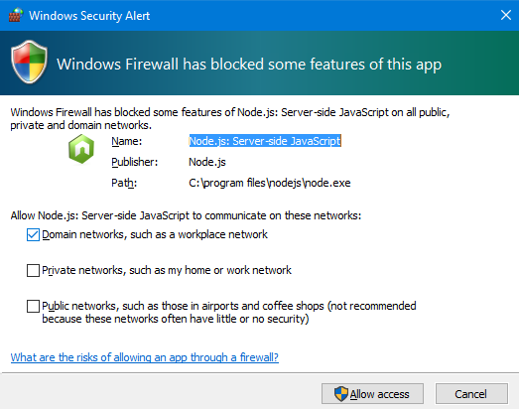

You now have your first Polymer site up! You may have to navigate to http://localhost:8080/

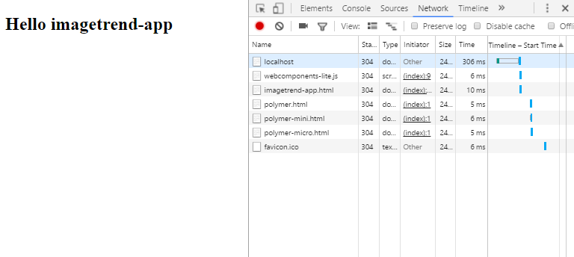

# Crash Course on Learning Polymer

## Folder Structure

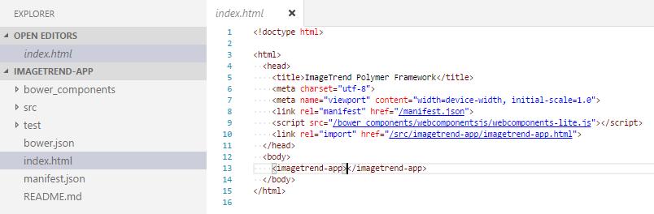

You can see that this looks like any other index.html file. The file above is the first file it hits and looks at the header information first. This file is the initializes polymer and the ImageTrend App. You can see that there is an import link to imagetrend-app.html. This will be your main app file. There are also a few folders. Folder bower_components holds all of your polymer assets and was generated when you typed bower install.

## Web Component Structure

Go to imagetrend-app.html

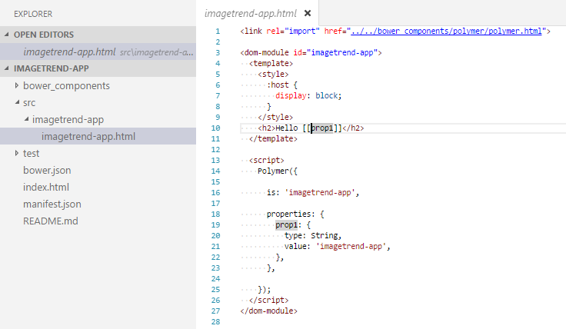

This is the general layout of the structure. Each component has all of its needed elements located at the top. Best practices are to import all elements that are included in the component even if a parent component has that element.

The component is wrapped with the <dom-module> tag. The id is set to what the element is called. In this case it is called imagetrend-app. Inside the <dom-module> tag are a few other things. The <template> tag is what is mainly placed onto the dom and the script tag has the Polymer element registration stuff. This is where you name the element set properties and methods on the element's prototype.

The property prop1 is a variable string, with the default value of imagetrend-app. That’s what you see when you run the site.

I won’t be covering the details of what things the Polymer registration part because…no. But there’s plenty of things later on and even more online.

<https://www.polymer-project.org/1.0/docs/devguide/feature-overview>

## Elements

<https://elements.polymer-project.org/>

This is a fun place to be. But I’ll just quick go through how to get the element you want. For example, we will probably want the cool <paper-button>. So we can navigate/search to paper-button.

<https://elements.polymer-project.org/elements/paper-button>

There will be links for Docs, Demo, and Source. You should be able to figure out that most of the spec and how to use information will be in the Docs link. There will be a command to install the component that we will run in the command prompt.

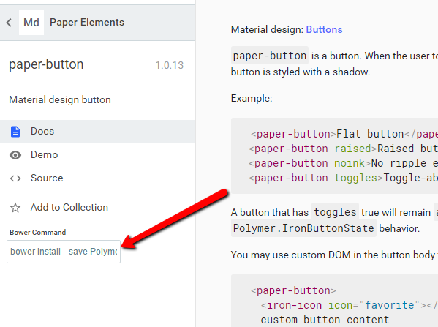

Boom that was easy. Now let’s place it in our app.

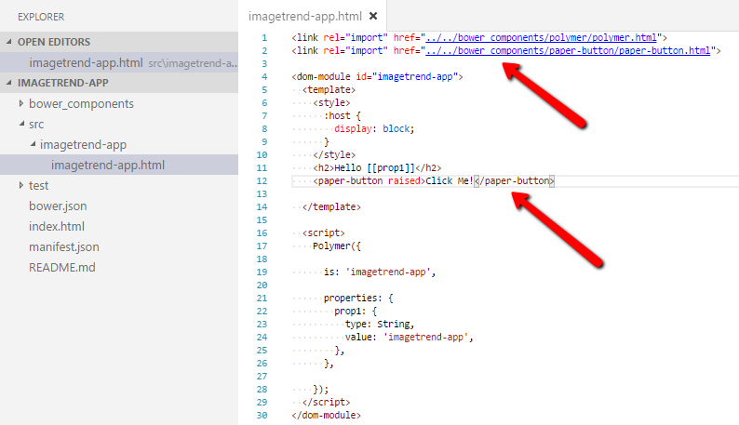

Now go to <http://localhost:8080/> and refresh your browser and you should see a flashy button appear. These are the general steps in adding a new polymer element.

# Making a Framework

## URL Route Based Pages

Think of one of our products. You would agree there are different layouts in certain pages. The URL is a good indicator of what page you are in and polymer can handle it.

The <app-route> and <app-location> are the main elements that will handle your URL. Install them. You should be able to read more about these in the Element Catalog.

bower install --save PolymerElements/app-route

Remove the <paper-button> element and place <app-route> and <app-location> in.

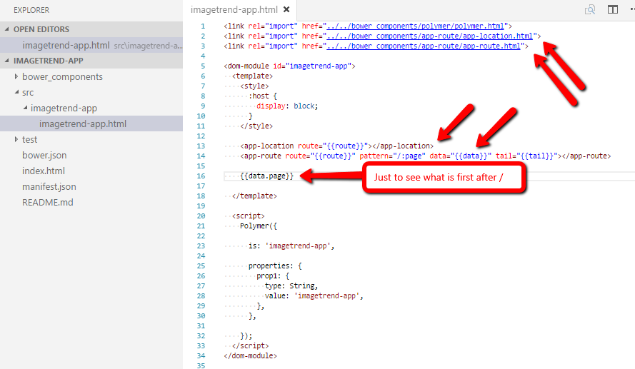

You will see that if you put an address like <http://localhost:8080/home>, the {{data.page}} will display home. This is a clue for how to handle what page we want to use. To handle this, we will include <iron-pages>. Also add some pages like the image below.

bower install --save PolymerElements/iron-pages

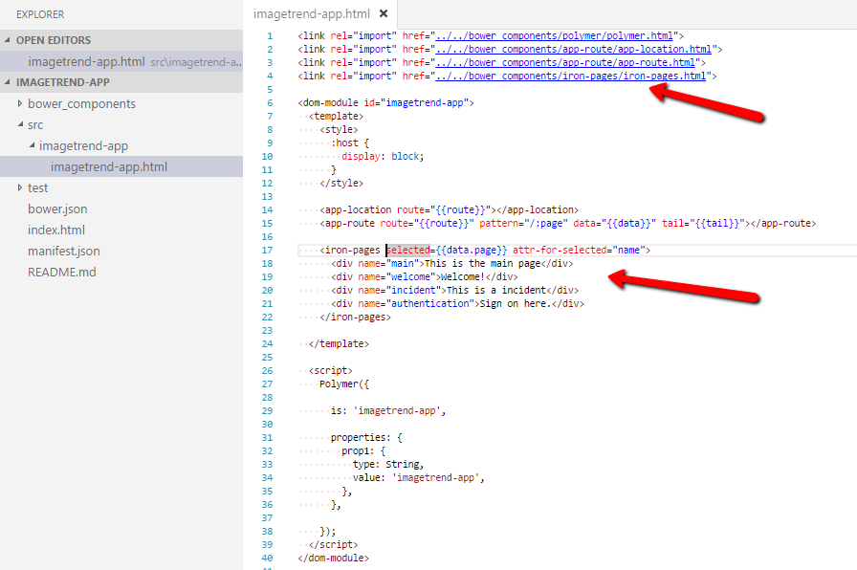

Go to <http://localhost:8080/welcome>. You will now see that this page will show the contents between the div.

Now the cool thing is we can add Polymer elements as pages however each page may be related to other pages and will have similar layouts. Some pages will have a tool bar at the top and some won’t like an incident page more or less. To handle this, we will develop the idea of container iron pages.

## Container Iron Pages

Create a folder called containers in the imagetrend-app folder. Create three files in the containers folder: imagetrend-authentication.html, imagetrend-main.html, imagetrend-incident.html. The files will look like:

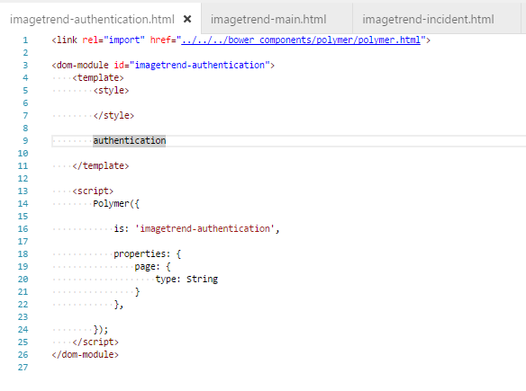

Note, you will have to add this code to main and incident but replace the authentication word only. Also, we need to beef up our iron-pages and functions in imagetrend-app.html.

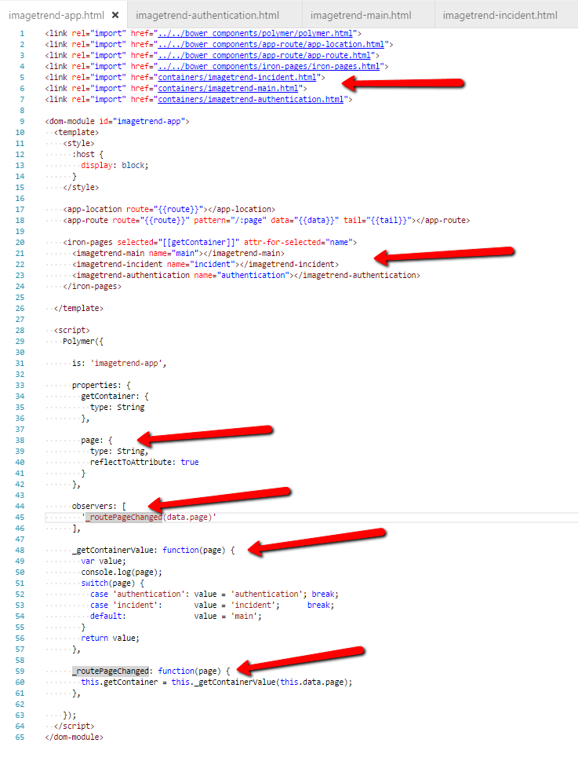

Above we add the polymer elements in the <iron-pages>. We have create an observer object that will observe any changes to data.page. Then we will add functions to handle what container to use. This will make more sense when we handle different pages.

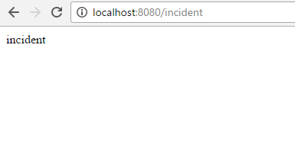

You should see these containers load. They will default to main.

## Container Page Handling

So these containers will have pages that will exist in within them and we will try follow what the containers have done. First create a folder called pages under imagetrend-app. Create six files in the containers folder: imagetrend-dashboard.html, imagetrend-incident-page.html, imagetrend-list.html, imagetrend-settings.html, imagetrend-signon.html, imagetrend-signup.html. The six files will look like:

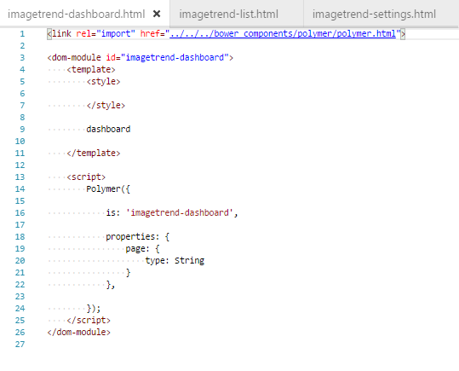

We will also modify the imagetrend-app.html file once again. The changes will allow the ability to select what container to use depending what the page is. The only changes will be in the element registration area. The file will look like:

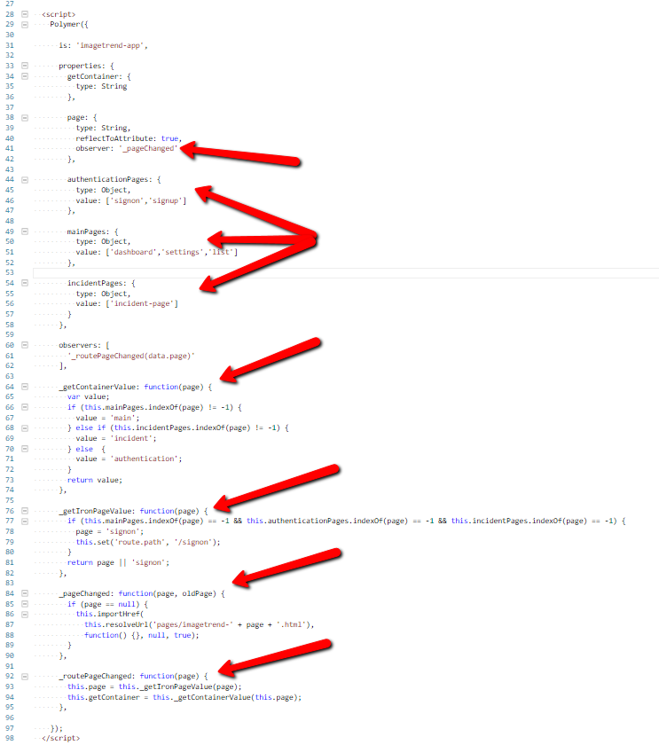

Careful, most of it is new or has been changed. Lastly, we need to handle the routes per container. Change these files

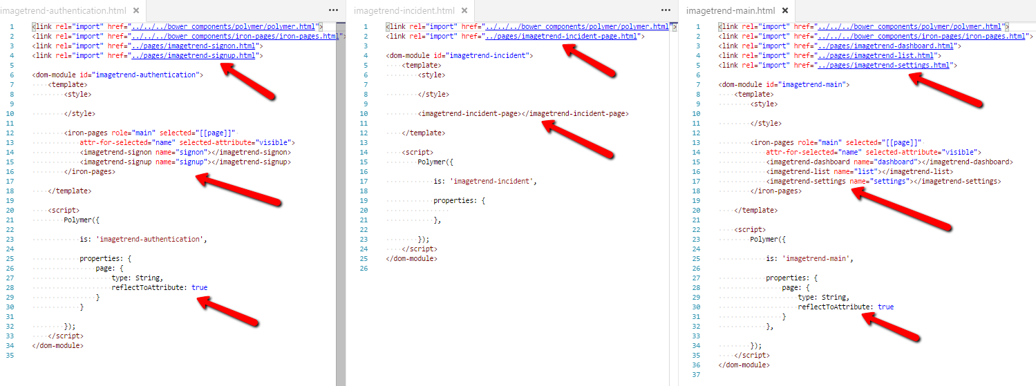

# Creating An App

Now we can start adding elements to get an idea of how powerful polymer really is. We will start with adding bits and parts to just give you the ideas of how to use certain things. After that, you should have the tools and knowledge to extend this.

## Authentication

Unfortunately, the scope of this document does not include setting up a Webservice to authenticate users. However, we can still mimic sign on and sign up. Let’s install inputs and buttons.

bower install --save PolymerElements/paper-input

bower install --save PolymerElements/paper-button

Before we add the buttons lets handle page routing if a link is clicked say the sign on button. This will be explained later.

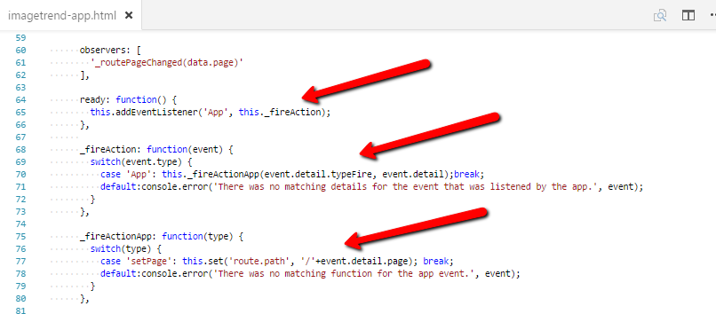

These three new blocks are what we call custom events. These will be expanded on if you include more functionality. Especially if there are more complex stuff you want to add. Kind of like a state transition diagram. But this is the first level of interaction with the backend. Then we want to edit the pages to show the inputs and buttons. Below is what to add.

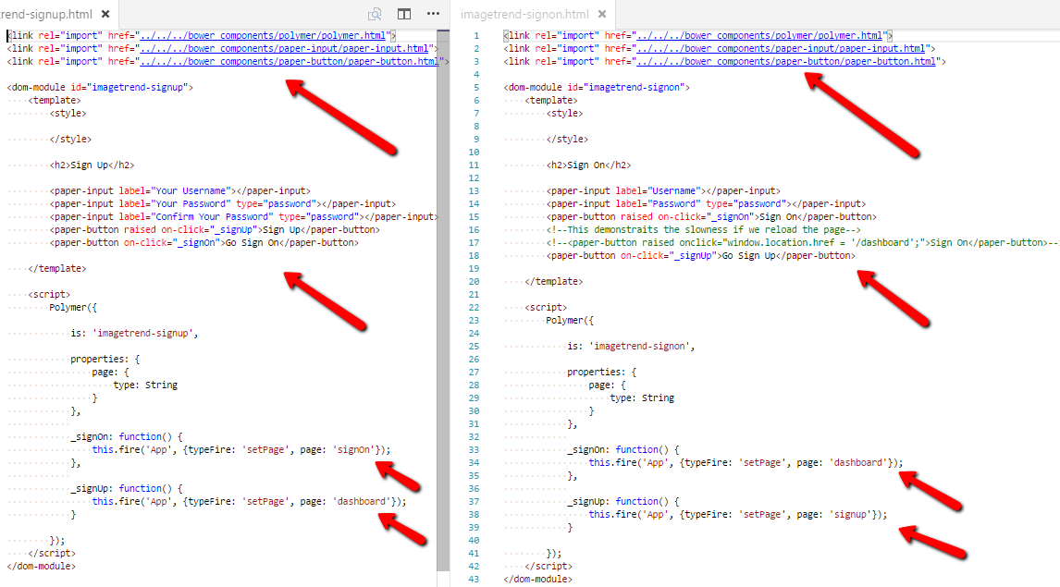

You will now be able to go back and forth between sign up, sign on, and the dashboard. Note: still need validation and an actual Webservice to hook up to.

## Dashboard

Let’s add some stuff and fill that think up!

bower install --save PolymerElements/paper-card

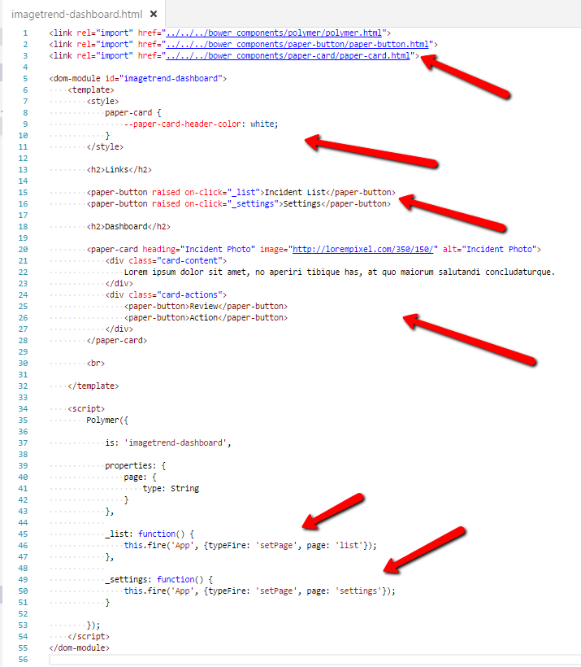

## Settings

Just add a dashboard button link and a sign off button link.

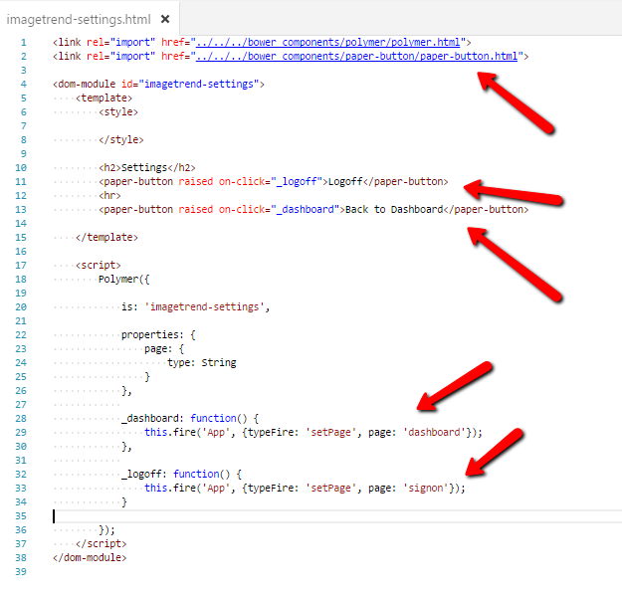

## Incident List

bower install --save PolymerElements/paper-item

bower install --save PolymerElements/paper-icon-button

Change file as show below.

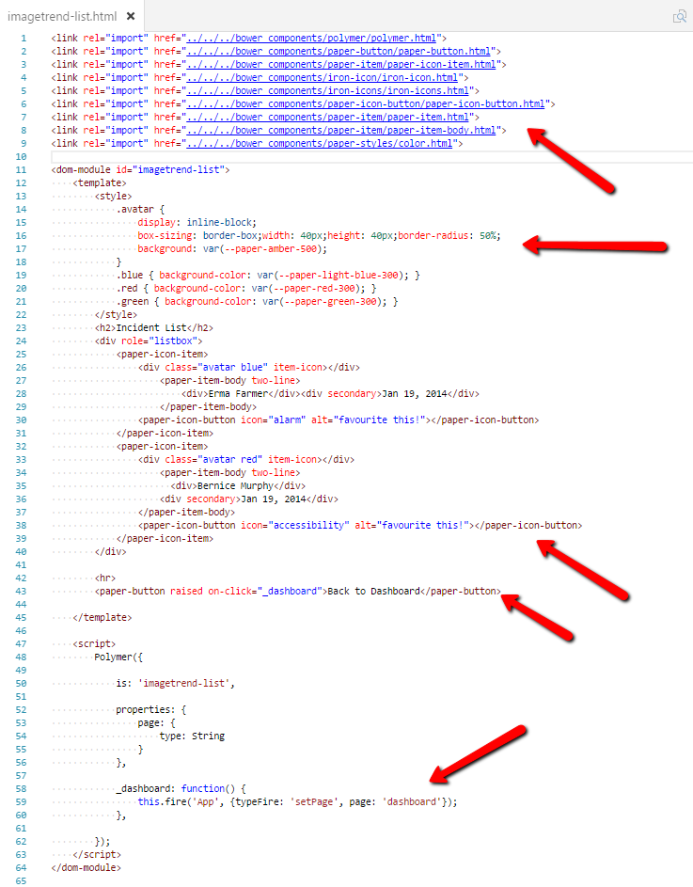

## New Incident

bower install --save PolymerElements/paper-radio-button

bower install --save polymerelements/paper-listbox

bower install --save PolymerElements/paper-dropdown-menu

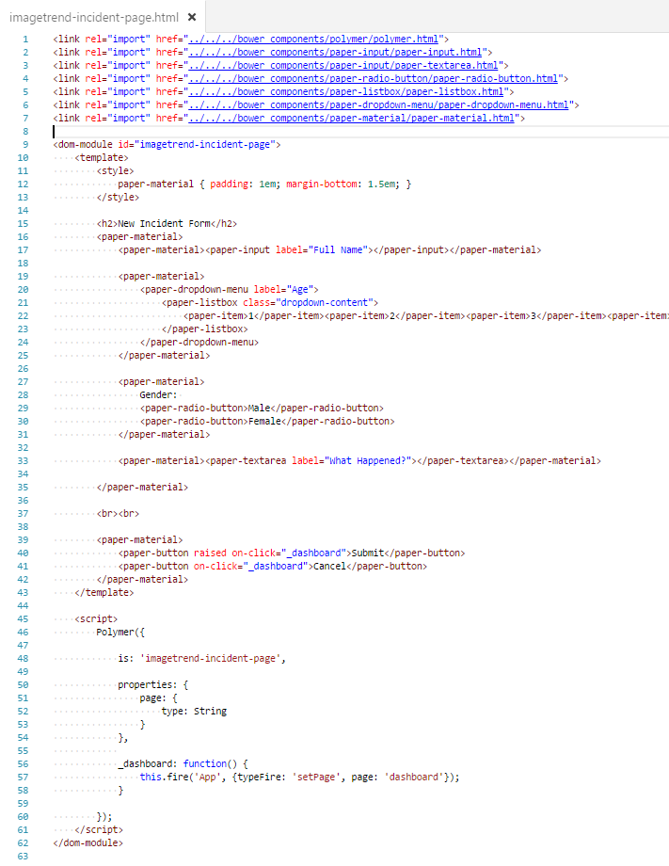

This should be the last example for the pages go. Hope it all works.

# Toolbar

This is the last part and will not do much but will demonstrate the power of the idea earlier of containers.

bower install --save PolymerElements/paper-toolbar

Modify imagetrend-main.html and only pages that are under the main folder will have a toolbar.

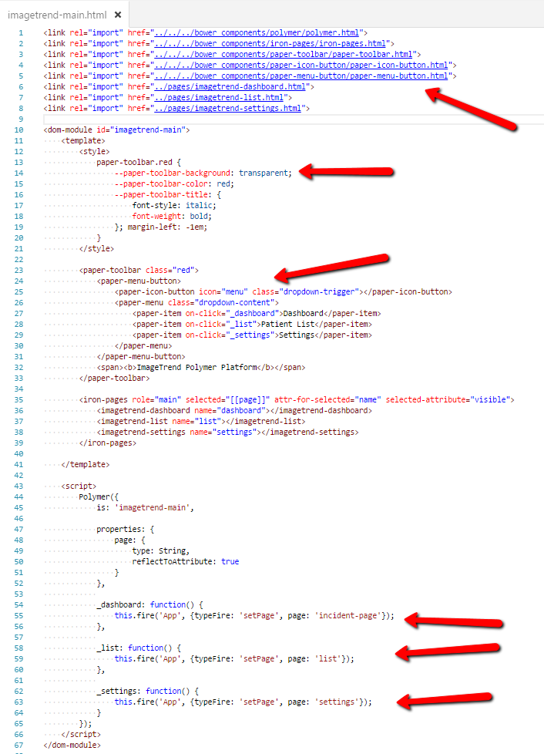

# Wrap Up

This ends setting up and learning how to put together a basic polymer framework.